CD Review with Andrew McGregor
Saturday, September 28, 2014

American Chamber Music
James Ehnes, violin
Musicians of the Seattle Chamber Music Society
Onyx Classics, ONYX 4129

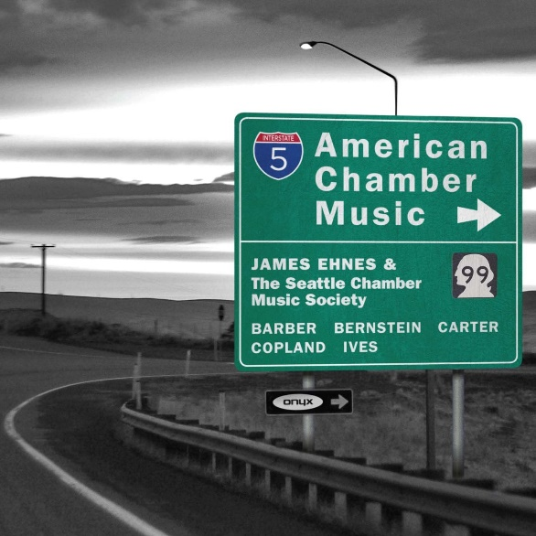
Let’s take an American diversion with James Ehnes and the Seattle Chamber Music Society. This is a beautifully assembled mix of some of the giants of 20thC Americana: Ives, Bernstein, Barber, Elliott Carter.
Here is Copland’s finale:
Aaron Copland, Sonata for violin and piano
3rd mvt: Allegretto giusto

But they begin with the Violin Sonata by Aaron Copland which doesn’t get out nearly enough. Maybe it needs a performance like this one from James Ehnes and Orion Weiss to make it fly.

I can’t remember when I’ve enjoyed it as much as I have in this new performance. And the bonus is that it is the opening work in a recital of highways and byways in 20thC American music that has been put together with skill and affection by Ehnes and the Seattle Chamber Music Society.
There’s Bernstein’s early Piano Trio, Samuel Barber’s String Quartet with its famous Adagio (yes, that B Adagio!), Elliott Carter’s Elegy, and a Largo by Charles Ives.
If it sounds appealing to you, you ought to love the performances. That’s new this month from Onyx Classics.

