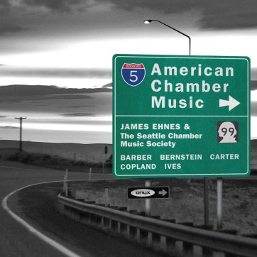
James Ehnes, musiques américaines
Pierre-Jean Tribot | Le 15 janvier 2015

TRANSLATION
Violinist James Ehnes and his friends from the Seattle Chamber Music Society allow us to discover a panorama of American chamber music
American chamber music remains relatively unknown on this side of the Atlantic. The brilliant virtuoso James Ehnes merits all our praise for offering us a panorama of two generations of great American composers. The trip begins with Charles Ives, the ‘spiritual father’ of the whole movement of modern music, followed by Copland, Bernstein, Carter and Barber.
The discoveries are many in this recording, beginning with Bernstein’s Trio for piano, composed when he was barely 20 years old. The imagination and inventiveness of the composer highlight the links to musical romanticism. Grand master of orchestration, Samuel Barber is also a virtuoso of chamber music composition as is evident in his superb String Quartet, with its autumnal colours. As for Copland’s Sonata for Violin, it caresses the ears with the beauty of its textures.
Master of ceremonies James Ehnes is perfect with his colleagues from the Seattle Chamber Music Society. Within the recent flood of releases, to discover one that is intelligent, original and magnificently played, is a delight.

